# INF10025 Distinction Task – Template

Enter your Student ID: 104071453 Name: Marco Giacoppo

## **Part 1 ERDs and Schemas**

### Narrative 1 ERD

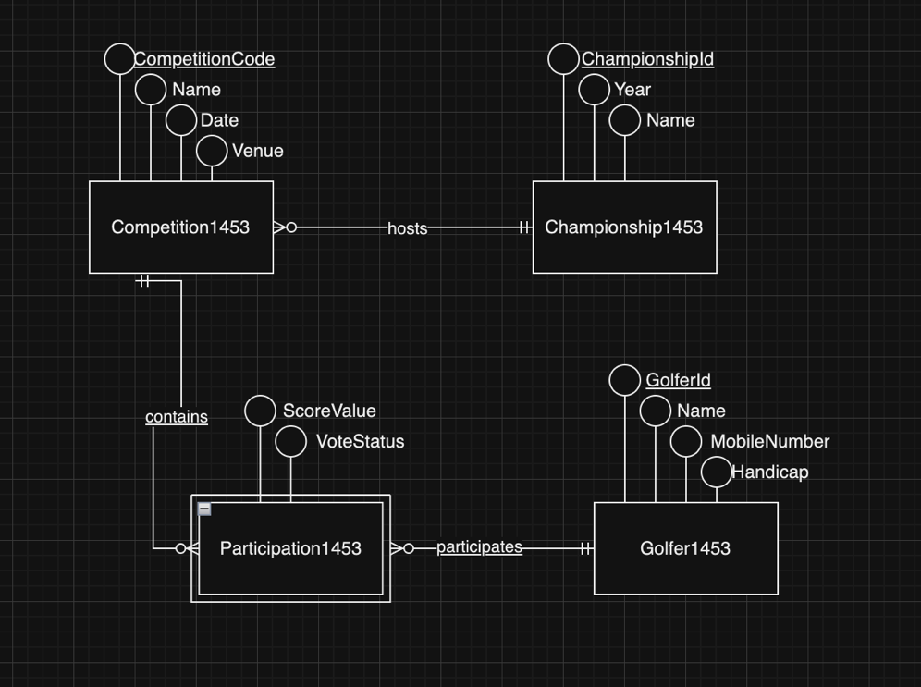 \

### Narrative 1 Schema

### 

### Narrative 2 ERD

### Narrative 2 Schema

## 

## **Part 2 Building Database**

Design Views and Datasheet views of 3 Tables created here.

## **Part 3. Queries and Insert Data**

### Q1. People Query

### Design:

### Result Set:

## Q2. Donation

### Design:

### Result Set:

## Q3. Gender

### Design:

### Result Set:

## Q4. Fastest

### Design:

### Result Set:

## Q5. Better than Average

### Design:

### Result Set:

## Q6. Persons with No Results

### Design:

### Result Set:

## Q7. XCategory

### Design:

### Result Set:

## Q7. Insert Your data and Event 25

### Result Set:

## **Part 4 Visualizations**

## Q1. Member Category Viz

### Settings:

### Visualization:

## Q2. Age Category Viz

### Settings:

### Visualization:

## Q3. X Category Viz

### Settings:

### Visualization:

## Q4. Event Viz

### Settings:

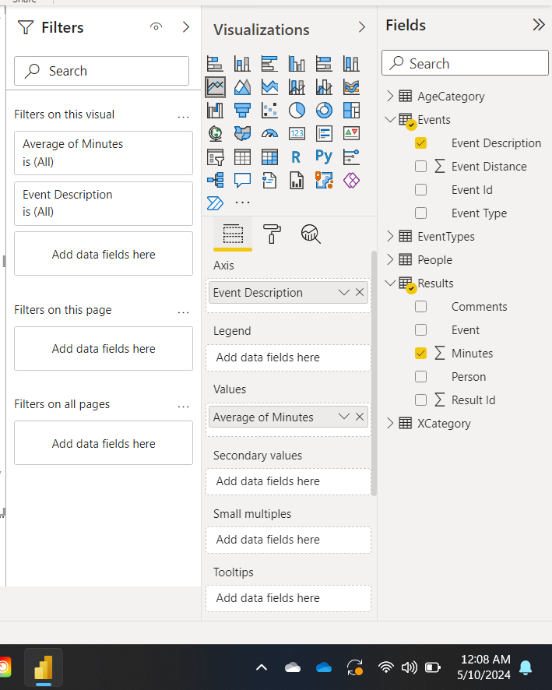

### Visualization:

## Q5. Event 25 Viz

### Settings:

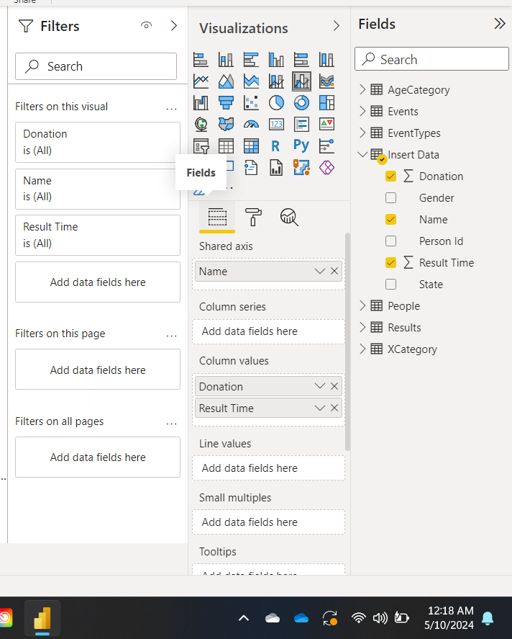

### Visualization:

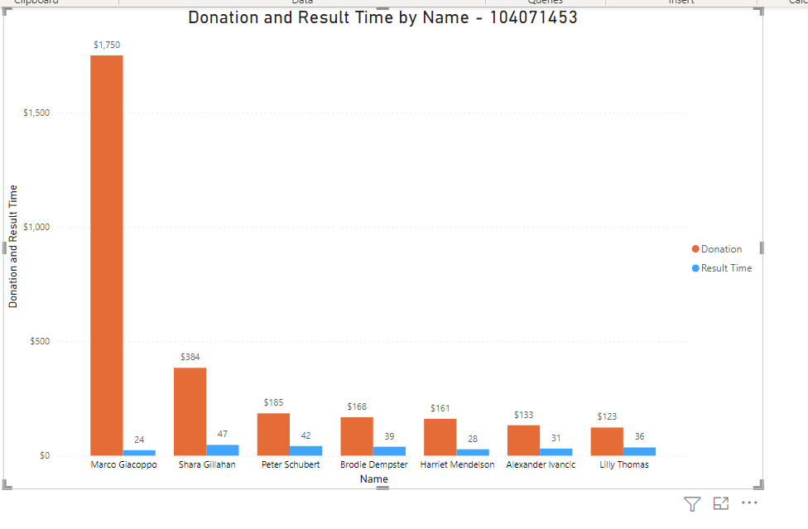

## Q6. Extra Viz 1

### Settings:

### Visualization:

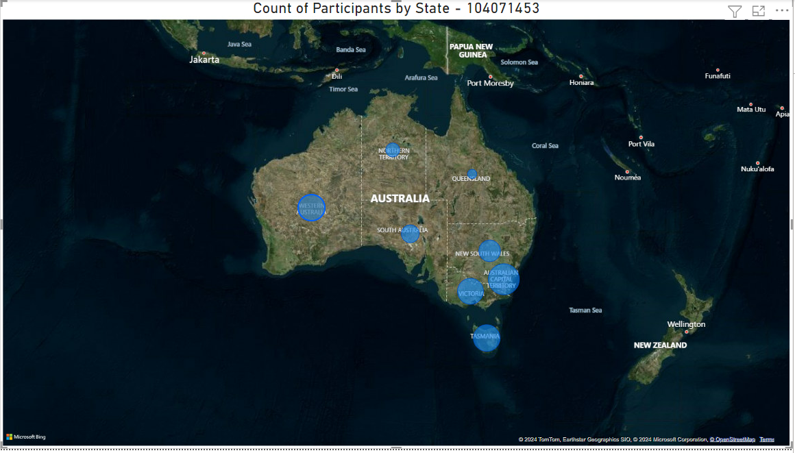

## Q7. Extra Viz 2

### Settings:

### Visualization:

